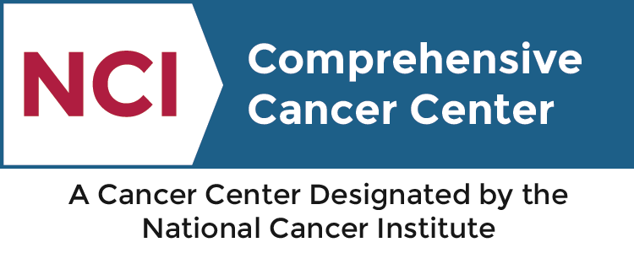


Rutgers Cancer Institute of New Jersey

The Cancer Center Grand Rounds

Presents

Nathaniel Daw, PhD
Huo Professor in Computational and Theoretical Neuroscience
Princeton Neuroscience Institute and Department of Psychology
Princeton University

“Machine Learning Applications to
Behavioral Science and Beyond”

Host: | Carolyn Heckman, PhD  Associate Professor of Medicine  Division of Medical Oncology, Section of Population Studies  Rutgers Cancer Institute of New Jersey  Rutgers Robert Wood Johnson Medical School
Zoom: | Pre-Registration is required.  Register in advance for this meeting:  https://rutgers.zoom.us/meeting/register/tJ0pdeiqpjoiE9LpE9UggMzRtHN_mzYbMImQ  After registering, you will receive a confirmation email containing information about joining the meeting. Do not forward link
When: | Wednesday, May 5, 2021
Time: | 4:00-5:00 PM

For information, please call 732-235-3957
Kristi Parker, parkerkn@cinj.rutgers.edu

