Population Health Consortium

Agenda

February 3, 2025

11:00 AM – 12:30 PM

Meeting Link:

https://rutgers.zoom.us/j/92311349413?pwd=S3c2csVJGUxalazNMPUddJeGsBMz6D.1

Topic | Speaker(s) | Time
Welcome | Ethan Halm | 5 minutes
Office of Population Health Updates | Ethan Halm | 10 minutes
Well-being at Rutgers: Something for Everyone | Reka Somodi DNP, APN  Senior Director, Promotion of Well-being  Rutgers Health Office of Clinical and Health Affairs  Margaret Swarbrick, MD  Associate Director, Center of Alcohol & Substance Use Studies; Research Professor, Graduate School of Applied and Professional Psychology  Chantal Brazeau, MD  RBHS Chief Wellness Officer | 45 minutes
Meeting Wrap-up  - Next meeting June 2, 2025 | Mary O’Dowd | 5 minutes

Population Health Consortium
Presenter Bio
February 3, 2025

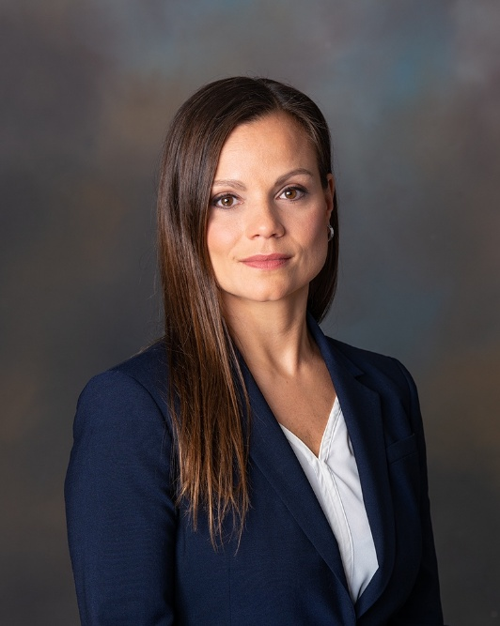

Reka Somodi is an accomplished academic clinician, educator, and innovator in nursing, advanced practice, and well-being. She has vast experience in trauma and surgical critical care as a nurse practitioner, has developed institutional programs for advanced practice providers, and has ensured the next generation of quality nurse practitioners as clinical faculty at the University of Pennsylvania’s School of Nursing in the Adult-Gerontology Acute Care Nurse Practitioner Program. She was integral in forming the first hospital-based advanced practice program at Robert Wood Johnson University Hospital, the first surgical intensive care advanced practice model at Jersey Shore University Hospital, has been a senior clinician at Penn Medicine and the Philadelphia Veteran’s Administration, and was the Critical Care Course Director for the Critical Care Advanced Practice Fellowship at the University of Pennsylvania. During these experiences, she was tasked with well-being content development and initiatives both academically and clinically which inspired her to complete her doctorate in nursing practice with an interest in clinician well-being. She joined Rutgers Health as the director for the Promotion of Well-being in February, 2024.

Population Health Consortium
Presenter Bio
February 3, 2025

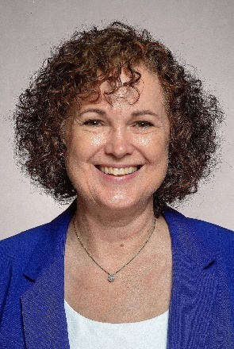

Dr. Chantal Brazeau has been a faculty member at Rutgers New Jersey Medical School since 1995 where she is Professor of Family Medicine and Psychiatry. She has been Director of Medical Student Education and Interim Chair of the Department of Family Medicine.
Throughout her academic career, she has taught about professional well-being and has conducted survey-based studies on medical student, faculty and physician well-being. She has presented at national and international venues on this topic.
She has served as Assistant Dean for Faculty Vitality at New Jersey Medical School since 2016 and assumed that role at Robert Wood Johnson Medical School in January 2020. She was announced as the inaugural Chief Wellness Officer at Rutgers Health in December 2019. She works closely with school, university and hospital leadership teams to explore and lead the development and implementation of well-being initiatives for faculty, staff and health care professionals.

Population Health Consortium
Presenter Bio
February 3, 2025

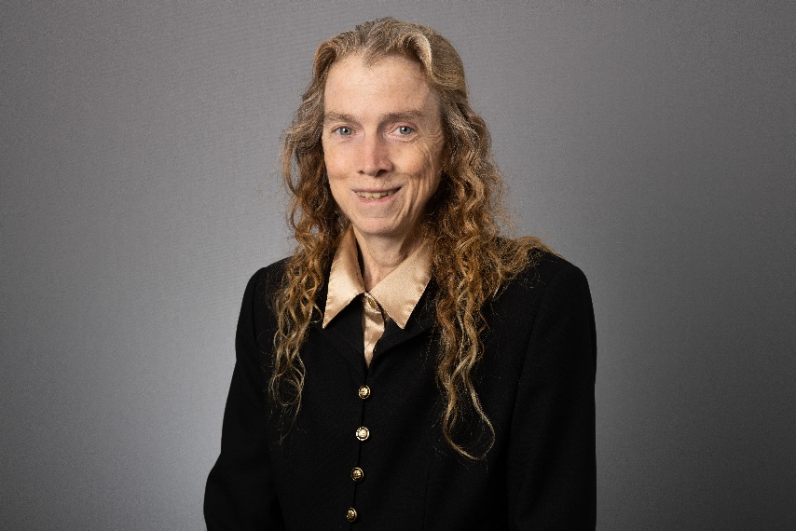

Dr. Swarbrick is the Associate Director of the Center of Alcohol and Substance Use Studies and a Research Professor in the Applied Department of GSAPP. Over her career, she has made significant contributions to the body of literature in occupational therapy, nursing, and community behavioral health care practice, focused on topics such as the 8 dimensions of wellness, wellness coaching, peer support, health disparities and social determinants of health, financial wellness, employment, trauma, and self-care. She developed a strength based 8-dimensional wellness model to promote recovery from mental health and substance use. Dr Swarbrick is known for bringing the voices and needs of people to the table by collaborating with the peer community and family groups to identify and address social determinants that are barriers to recovery and wellness. She has created self-care wellness programs for people in recovery, caregiver’s, families, youth, and professionals. She worked for many years at the Collaborative Support Programs of New Jersey Wellness Institute.

